**Set up My SQL Database on Docker**

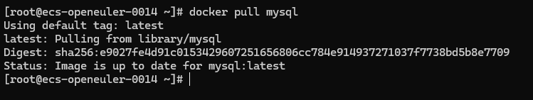Step 1: Pull mysql image

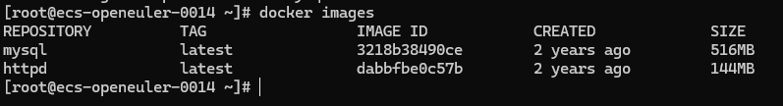Step 2: Check the docker image

Step 3: Run mysql Images



Step 4: check the container if database is up and running

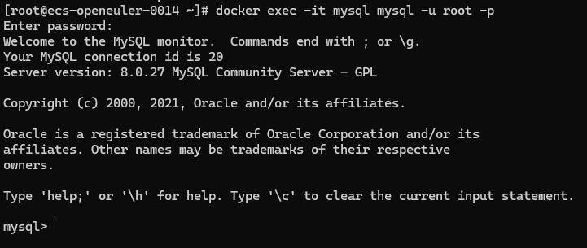Step 5: Login into mysql

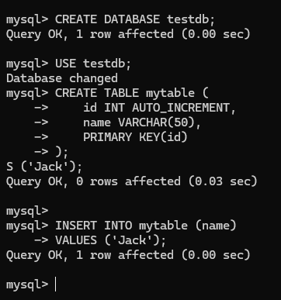Step 6: Setup database and table